Web Application Security Assessment and Incident Response Simulation

ApexPlanet Cybersecurity Internship — Task 5
Student: Himamrutha Aluri
Project: Web Application Security Assessment and Incident Response Simulation
Application: Damn Vulnerable Web Application (DVWA)
Environment: Local Docker lab
Assessment date: 13-10-2026

1. Abstract
This project involved assessing a deliberately vulnerable web application in a controlled local lab environment. The work focused on inspecting HTTP responses and security headers, testing selected web application vulnerabilities, documenting potential risks, recommending mitigations, and reviewing available application logs.
The project provided practical experience with basic web application security testing, evidence collection, risk assessment, and incident-response documentation.

2. Objectives
- Inspect the local application's HTTP behavior.
- Record response headers and authentication behavior.
- Assess SQL injection and XSS using DVWA training modules.
- Document evidence and potential impact.
- Recommend suitable remediation measures.
- Review available logs and document an incident-response workflow.
- Maintain a structured technical repository.

3. Scope and Environment
The assessment target was DVWA running locally at http://localhost:4280 through Docker.
Testing was restricted to the local training application. No third-party systems were included in the scope.
Tools used:
- Kali Linux
- Docker
- DVWA
- Browser
- CURL
- Burp Suite.

4. Methodology
The assessment followed these stages:
- Confirm application availability.
- Inspect HTTP status codes and redirects.
- Review response headers and authentication behavior.
- Test selected DVWA vulnerability modules.
- Capture screenshots and record observations.
- Assess potential impact and assign preliminary severity.
- Document mitigations and retest status.
- Review available logs and record incident-response observations.
5. Diagram
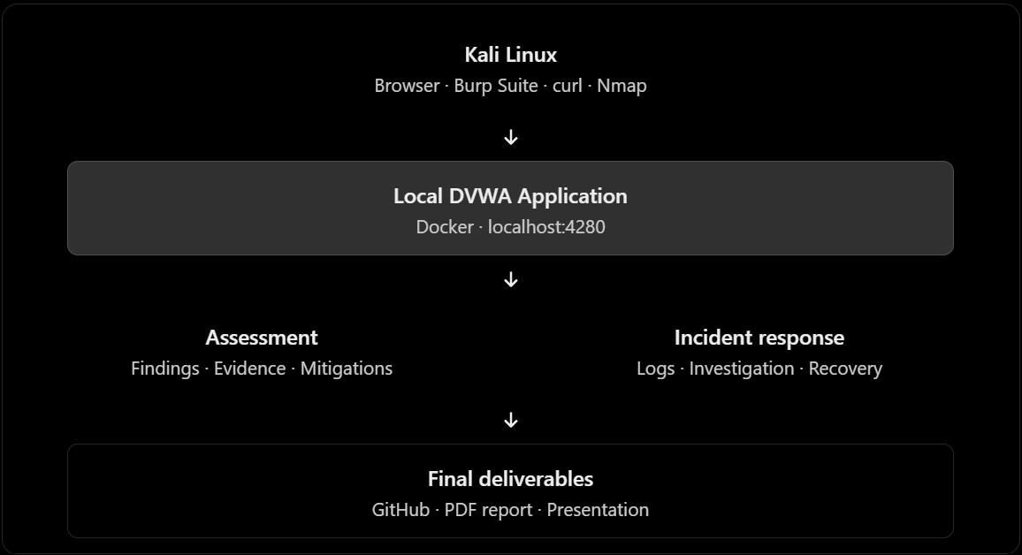

6. Finding: SQL Injection
Status: Confirmed
Severity: Low
Description: SQL injection can occur when untrusted input changes the intended logic of a database query.
Test input: 1' OR '1' = '1
Observed result: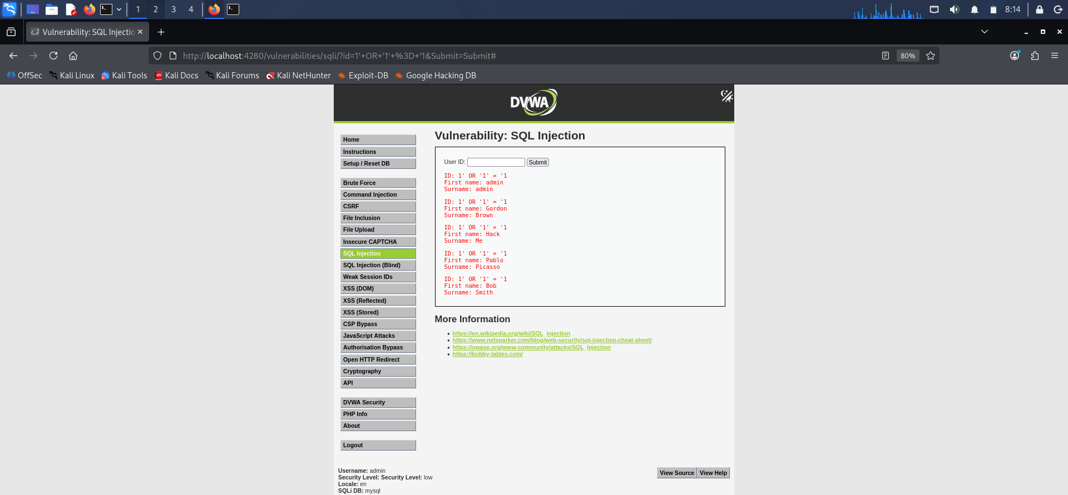
Potential impact: SQL injection may allow unauthorized database record retrieval or other database actions, depending on the vulnerable query and database permissions.
Recommended mitigation: Use parameterized queries, apply appropriate input validation, restrict database privileges, and avoid exposing detailed database error.

7. Finding: Cross-Site Scripting
Status: Confirmed
Severity: Low
Description: XSS may occur when untrusted content is processed or rendered in a way that permits unintended script execution in a browser.
Test performed: harmless test input
Potential impact: If confirmed, XSS may allow unintended script execution in a user's browser and interfere with user interactions.
Mitigation: Apply context-aware output encoding, use safe templating and DOM practices, and sanitize HTML where HTML input is intentionally supported.

8. HTTP Security Header Review
Previously observed responses included X-Content-Type-Options: nosniff, X-Frame-Options: SAMEORIGIN, and Referrer-Policy: strict-origin-when-cross-origin. Include these in the final results only if reconfirmed during this assessment.
Recommended controls depend on the application's deployment and may include Content Security Policy, appropriate framing restrictions, and HTTPS-related protections.

9. Risk Summary
Finding | Final status | Severity
SQL Injection | Confirmed | Low
Cross-Site Scripting | Confirmed | Low
Security-header observations | Confirmed | Low
Severity was determined based on the evidence collected, potential impact, and tested configuration. Unconfirmed tests are not reported as confirmed vulnerabilities.

10. Mitigation and Retesting
- Use prepared statements and parameterized queries instead of directly concatenating user input into SQL queries.
- Validate user input on the server according to the expected data type and format.
- Apply the principle of least privilege to database accounts.
- Avoid displaying detailed database error messages to users.
- Review the affected code and implement secure database query handling.

11. Limitations
The assessment covered only the local DVWA environment and selected tests. Results may vary with the DVWA security level, application configuration, and database permissions.
The exercise does not represent a comprehensive production penetration test or a fully automated security-monitoring deployment.

12. Conclusion
This project provided practical experience with web application reconnaissance, vulnerability assessment, risk documentation, mitigation planning, and basic incident-response procedures. It reinforced the importance of collecting evidence, distinguishing confirmed findings from assumptions, and validating remediation through retesting.

13. References
- OWASP Top 10: https://owasp.org/www-project-top-ten/
- OWASP Web Security Testing Guide: https://owasp.org/www-project-web-security-testing-guide/
- DVWA project: https://github.com/digininja/DVWA
- PortSwigger Web Security Academy: https://portswigger.net/web-security
- Docker documentation: https://docs.docker.com/
- CURL documentation: https://curl.se/docs/

